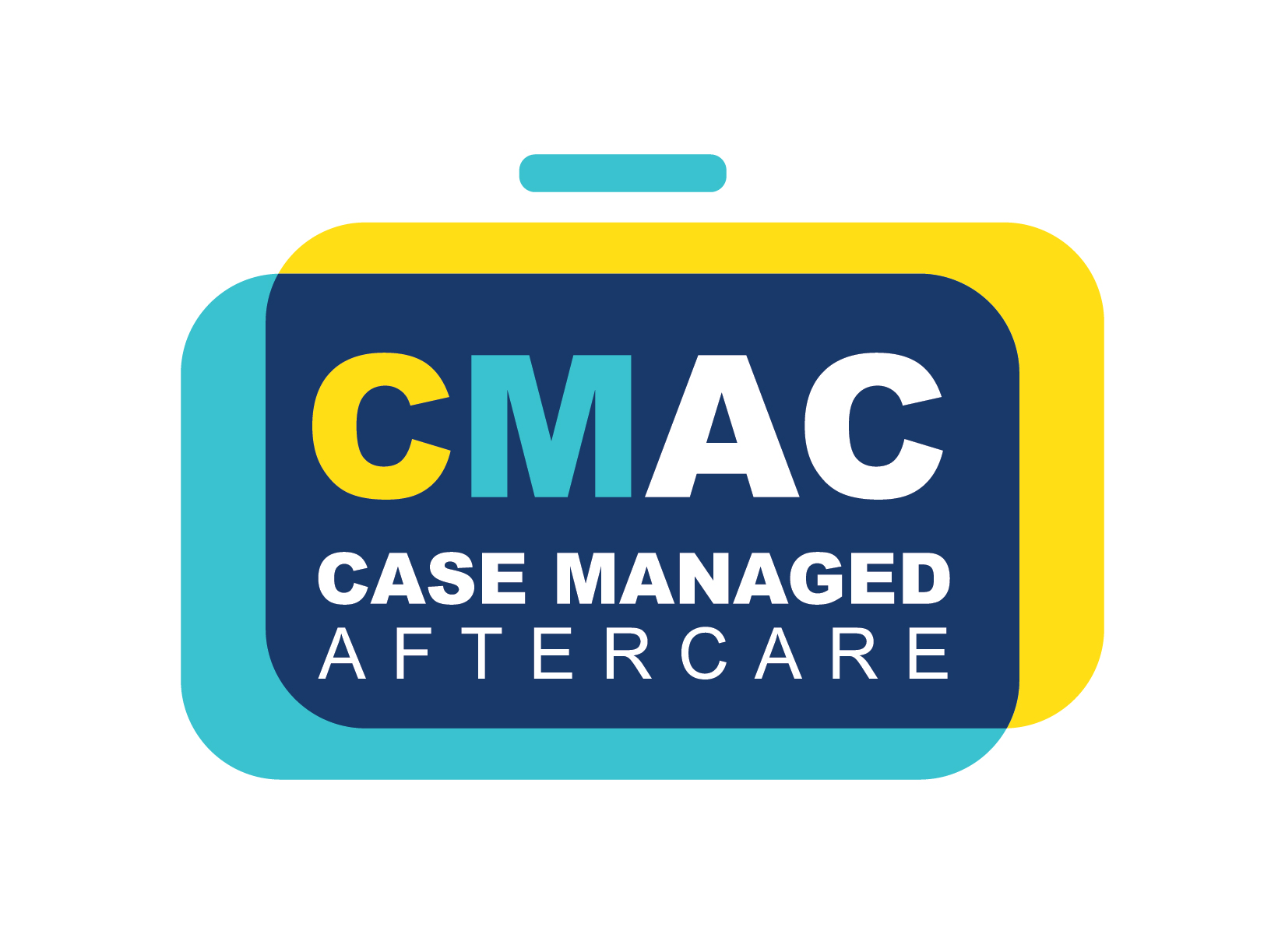

Comprehensive programs provided by CLRA on behalf of its participating contractors

[DATE]

[WORKER NAME & ADDRESS]
[WORKER TELEPHONE & CELL NUMBERS]

RE: Canadian Model and/or A&D Policy Violation on ______________________ (mmm/dd/yy)

As a worker/potential worker employed under one of the following collective agreements listed in A or B:

- CLR Industrial Construction, NMA Maintenance, GPMC Maintenance Collective Agreements for one of the following trades:

- Carpenter, Local 1325 & 2103
- Cement Masons, Local 222
- Insulators, Local 110
- Ironworker Reinforcing, Local 720 & 725
- Ironworker Structural, Local 720 & 725
- Labourers Construction General, Local 92
- Mechanical, Local 488 & 496
- Millwrights, Local 1460
- Operating Engineers General, Local 955
- Plasterers, Local 222
- Sheeters, Deckers, Cladders, Local 8 (for Industrial Construction only)
- Sheet Metal, Local 8

- Other Trades/Jurisdictions for one of the following trades:

- Shop Fireproofer, Local 222
- UA Fab Shop, Local 488

this letter outlines the processes that must be followed due to your recent A&D violation as required under our contractor CEFAP and CMAC programs with the collective goal of returning you to active status as quickly as possible.

As your employer/potential employer, we are required to:
- Provide you with effective worker/potential worker assistance services through our CEFAP & CMAC Programs.
- Within 10 days from date of violation:
  - Provide you with this letter to ensure you understand who does what to assist your ability to return to work.
  - Submit an electronic referral via www.clra.org that is automatically forwarded to the Third Party Case Administrator (TPCA) and your union.

As TPCA managing CMAC, they are required to:
- Upon receipt of a contractor referral, assign you a case manager that contacts you within 1 business day at the number you provided to us.
- If the number you provided us is no longer accurate, notify the undersigned immediately, failing to do so will cause delays that could affect your funding eligibility.
- Complete a second review of the assessment report with you once report received from SAE Team.

As our worker/potential worker, you are required to:
- If you have not received a call from TPCA within 1 business day of your notification of violation, call 780-493-0725 and engage with CMAC, they are your advocate and provide support to return you to work.
- Book and attend your SAE Assessment by calling the SAE Team at 1-877-822-0727 within 30 days from the date of violation. [If you are not eligible for full funding, your case manager or SAE Team can provide you with your funding/costing breakdown.]
- If dispatched in the last 60 days, be prepared to provide a copy of your dispatch slip.
- Provide a copy of your “Drug Testing Custody and Control Form” received from the testing facility.
- Promptly attend your SAE Assessment and, if applicable, post assessment counselling sessions.
- When services are attended virtually, contact Client Services for connectivity technical support at 1-877-822-0727 if you are having technical difficulties.
NOTE: If you choose not to participate or meet the required timelines, YOU MAY BE REQUIRED TO FUND ALL OR A PORTION OF SERVICES.

As the SAE Team managing CEFAP, they are required to:
- Determine eligibility status and A&D services funding model.
- Provide an assessment appointment with 3-5 business days of date of eligibility confirmation.
- If services, or a portion thereof, are offered virtually, provide prompt connectivity technical support at 1-877-822-0727 if a worker is having trouble accessing the online platform.
- Standard Case - Complete the assessment report & worker debrief within 5 business days of assessment date.
- Complex/Repeat Case - Complete the assessment report & worker debrief within 10 business days of assessment date.
- Release assessment report to workers’ case manager for second worker debrief.

For further information on our contractor provided A&D programs, please use the following link:
- https://clra.org/initiatives/

Regards,
[COMPANY NAME]

[WRITERS NAME]
[WRITERS EMAIL & TELEPHONE]

